

Sponsor and Trade Application 2022

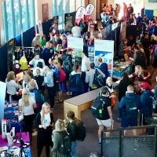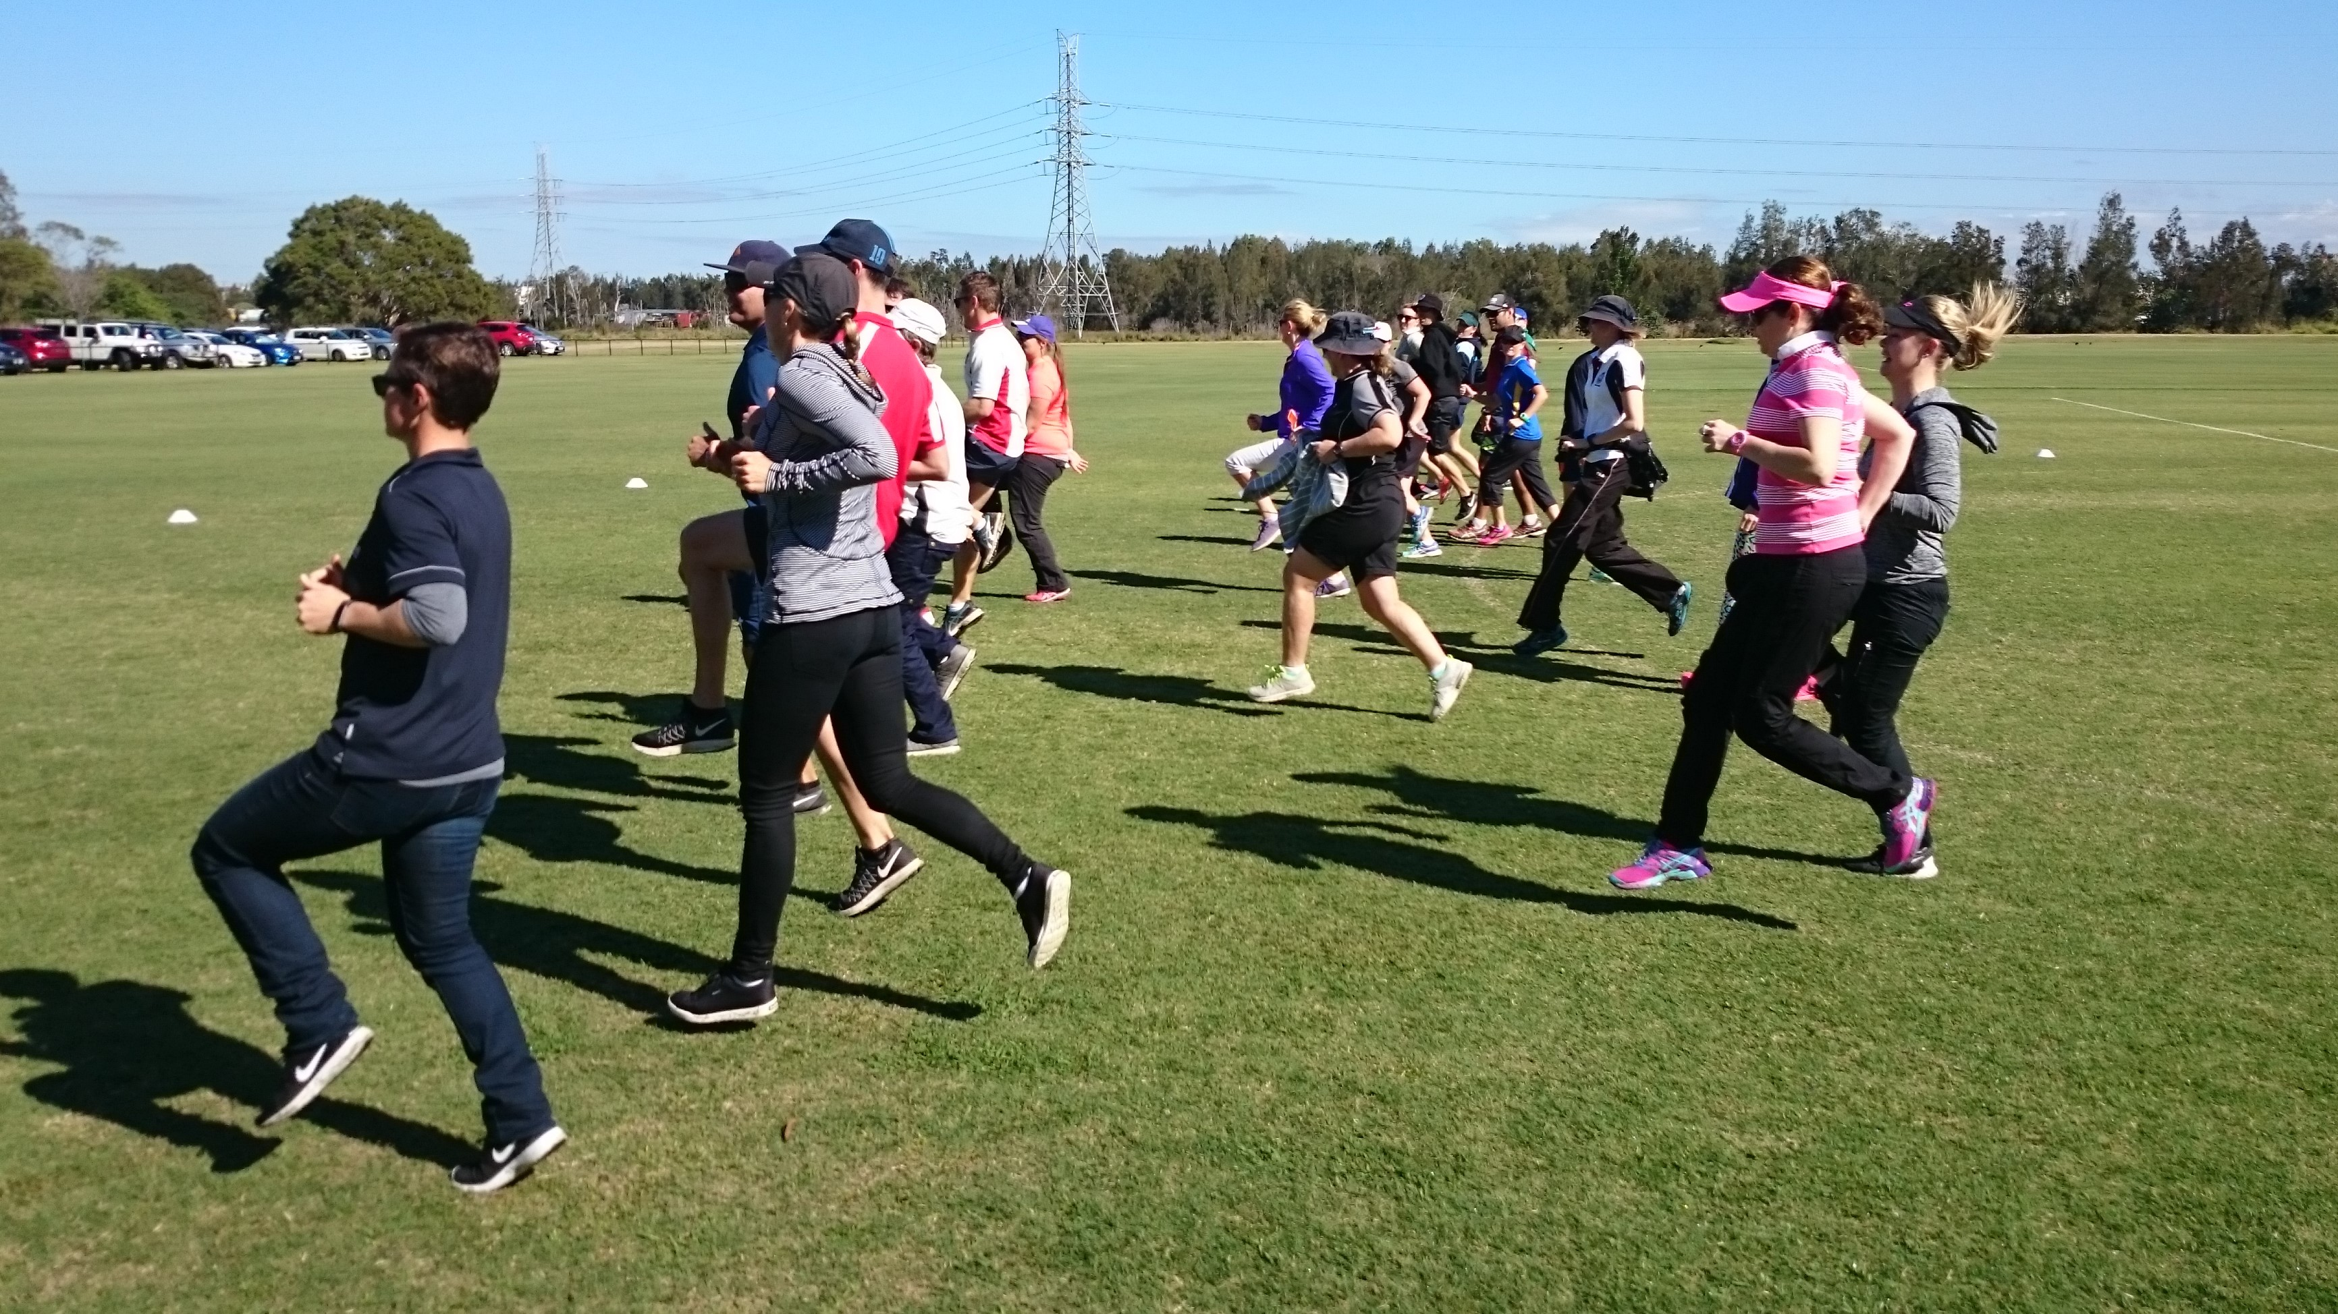

ACHPER QLD is a not‐for‐profit professional association representing teachers who work in the Health and Physical Education sector. ACHPER QLD provides quality professional development opportunities for educators (Primary and Secondary) and other education, health and sport and recreation industry members throughout Queensland.
Professional learning events are promoted to all schools (Government, Catholic and Independent), universities and other tertiary institutions throughout Queensland. ACHPER QLD and is recognised by teachers and principals as providing the key professional learning opportunities for Health and Physical Education (HPE) professionals. Teachers earmark the dates and travel from many regional and remote areas to attend.
A high proportion of delegates at professional learning events hold roles as Year Level Coordinators, Sport Coordinators, Heads of Departments or Head Coaches within their schools. These people are key decision makers in their schools. Furthermore, the delegates who attend ACHPER QLD professional learning events are innovative, motivated and passionate about the areas of health, physical activity and recreation, and are active, committed leaders and spokespeople in their school and community.
ACHPER QLD commands enormous respect within the educational community in Queensland. We invite you to take up the offers over the page and enjoy direct access to health and physical education educators from all over Queensland.

SPONSOR AND TRADE OPPORTUNITIES

Why Become Involved at an ACHPER QLD Professional Learning Event?
The benefits of becoming involved in an ACHPER QLD Professional Learning event includes opportunities to:
- gain direct access to members of the Health & Physical Education teaching profession
- promote your brand, product or service to potential clients and decision makers
- associate with the peak professional body for those employed in health, physical education and recreation teaching industry
- increase brand awareness and exposure through pre‐event marketing campaigns to over 3,000 school, education and related contacts in Queensland
- rapidly expand client base
- demonstrate a commitment to promoting active and healthy lifestyles
- showcase products and services to Queensland Primary and Secondary school communities.

Opportunities for face-to-face events in 2022:

- Sport and Recreation Conference 2 & 3 June in Brisbane – for teachers of Years 11 &12
Sponsor: $1,100 for 2 day conference (includes GST)
- Secondary HPE Conference 11 & 12 August in Brisbane – for teacher of Years 7-12
Sponsor: $2,200 for 2 day conference (includes GST)
Trade: $1,100 for 2 day conference (includes GST)
- PD4HPE 21 October on Gold Coast – for primary PE teachers
Sponsor: $550 for 1 day conference (includes GST)

Sponsor Benefits State Conferences & PD4HPE
- Six week advertising campaign leading into events to over 3,000 contacts
- Branding on website, social media, all EDMs containing event promotion
- Acknowledgement at conference opening and closing addresses
- Free Standing banner displayed in main plenary room (supplied by sponsor)
- ½ x A4 advertisement in conference handbook, given to each delegate (landscape)
- Priority placement of trade display for best foot traffic
- 3 x complimentary conference registrations and meals for company attendees
- All benefits of trade display below (except 2 registrations, see above)

Trade Display Only Benefits State Secondary HPE Conference
- Trade Display including skirted trestle table, tablecloth, chair and power
- 2 x complimentary conference registrations and meals for company attendees
- ¼ x A4 advertisement in conference handbook, given to each delegate (portrait)
- Logo and weblink on ACHPER QLD web page for Conference

2022 Sponsorship and Trade Application

Company:
Contact Person:
Email:
Phone:

I would like to take advantage of the following sponsorship/trade opportunity:

Please type YES in either the sponsor or trade box to indicate your preference.

Event | Days | Participants | Trade | Sponsor
Sport & Recreation State Conference | 2 days | 80 per day | No trade
Secondary HPE State Conference | 2 days | 280 per day
PD4HPE | 1 day | 80 per day | No trade

Conditions:

At the Secondary HPE Conference the position of trade exhibit spaces will be based on sponsors having priority. Trade exhibitors will be allocated the better positions according to the date in which applications are received.

Due to privacy law ACHPER QLD is unable to share delegate information with sponsors or trade displays.

All invoices must be paid within a month of issue. The popularity of ACHPER QLD events means there are often waiting lists. If an invoice is not paid by its due date the waiting list will be opened to the next sponsor/trade in line.

If more company representatives attend your exhibit than the number included in your package, a cost of $55 per day per person will be charged to cover additional food costs.

Please return to Bronwyn at executiveofficer@achperqld.org.au

